An Inflammatory Theory of Brain Disease

By Lauren Aguirre on Wed, 25 Feb 2015
Beginning in March, 2010, 882 men and women who had suffered traumatic brain injury were enrolled in a clinical trial to test whether administering the human hormone progesterone within four hours would improve their outcome. While it’s often thought of as a one-time event, traumatic brain injury is better described as a disease: it’s irreversible, sometimes progressive, and often affects people for the rest of their lives. More than 5 million Americans—ranging from professional football players to Iraq war veterans and victims of car accidents—live with disabilities caused by traumatic brain injury.
One striking hallmark of traumatic brain injury is inflammation in the brain, which occurs shortly after the trauma and can cause swelling, tissue breakdown, and cell death. Because it can be so debilitating, a lot of research has gone into finding ways to limit the damage in the hours immediately following injury. Progesterone can interfere with inflammation and is also thought to stimulate repair, so it was considered a promising candidate for reducing brain damage. Plus, the hormone is cheap and widely available.
Experimental animal models and two early, small clinical trials had all shown positive results. After years of failing to find effective medications, hopes were high for this new approach.

The Role of Inflammation
While inflammation is harmful in the case of traumatic brain injury, it is also critical for our survival. When our immune system encounters a microbe or when we bruise our knees, the inflammation that results rushes key cells and proteins to the site to fight the infection or to encourage healing. But there are times when inflammation doesn’t know when to quit, and many doctors and researchers believe it plays a role in many chronic diseases. The growing list goes beyond autoimmune diseases, such as arthritis, diabetes, or multiple sclerosis, to include cardiovascular disease and possibly even brain diseases such as Alzheimer’s, Parkinson’s, epilepsy, or depression.
Here’s how the immune system is supposed to work. Let’s say you slam a car door on your finger. That causes tissue damage and possibly infection—stuff that doesn’t belong there and looks foreign to the body. White blood cells and other molecules swarm in, wall off the damaged area, and attack the invaders and the damaged tissue. The area gets hot, red, swollen, and painful. Clean-up cells like macrophages—which means “big eaters” in Greek—gobble up the garbage. Once the damage has been contained, other immune molecules begin the repair process and the inflammation subsides.
But inflammation also causes collateral damage, a sort of friendly fire. The same processes that get rid of foreign agents can damage good cells as well. The death of those cells can in turn trigger further inflammation. For reasons that remain unclear, sometimes this creates a vicious cycle that becomes self-sustaining. Steven Meier, a neuroscientist at the University of Colorado who researches how the brain regulates immune responses points out that, “like many, many other adaptive mechanisms that are adaptive when they’re activated briefly, they may not be so adaptive when they’re activated chronically.”
For decades, researchers have noticed a link between ongoing inflammation and cardiovascular disease. Today it’s widely accepted that the immune system’s response to plaques of low-density lipoproteins, or LDL, on blood vessel walls plays a pivotal role in the progression of the disease. Sensing these plaques as foreign invaders, white blood cells and other molecules that are meant to protect the body turn into its own worst enemy. Instead of healing the body, white blood cells become trapped inside the plaques, provoking further inflammation and allowing the plaques to continue to grow. Eventually one of those plaques can break off and cause a clot, with potentially disastrous results.
Though it may be going too far to call inflammation a grand unifying theory of chronic disease, the link between the two is a focus of labs around the world. “I do think inflammation is an important element, and maybe at the heart of a variety of disorders,” Meier says, “and does account for a lot of the comorbidity that occurs between disorders. Why on earth is there comorbidity between depression and heart disease? But once you start thinking about inflammation, you realize they may be both inflammatory disorders or at least involve an inflammatory element.”
In the last decade, interest in the relationship between inflammation and brain disease in particular has exploded. Tantalizing associations abound. For example, some population-based studies of Alzheimer’s patients suggested that people who took non-steroidal anti-inflammatories—so-called NSAIDs like aspirin or ibuprofen—for long periods have a reduced risk of developing Alzheimer’s. Low-grade systemic inflammation, as measured by higher than normal levels of certain inflammatory molecules in the blood, have been found in people with depression. And in children with severe epilepsy, techniques to reduce inflammation have succeeded in stopping their seizures in cases where all other attempts had failed.

The Brain’s Immune System
The key is the brain’s unique immune system, which is slightly different from the rest of the body. For starters, it’s less heavy-handed. “The immune system, during evolution, learned that, ‘This is the brain, this is the nervous system. I cannot really live without it, so I have to be very, very, careful,’” says Bibiana Bielekova, chief of the Neuroimmunological Diseases Unit at the NIH.
The first line of defense for the central nervous system is the blood brain barrier, which lines the thousands of miles of blood vessels in your brain. It is largely impermeable, for the most part letting in only glucose, oxygen, and other nutrients that brain cells need to function. This prevents most of the toxins and infectious agents we encounter daily from coming into contact with our brain’s delicate neurons and fragile microenvironment, preserving the brain’s balance of electrolytes—such as potassium—which if disturbed can wreak havoc on the electrical signaling required for normal brain function. Normally the blood brain barrier is very selective about what it invites inside the brain, but when the barrier gets damaged, for example because of a traumatic brain injury, dangerous molecules and immune cells that aren’t supposed to be there can slip inside.
The second line of defense are microglia, the brain’s specialized macrophages, which migrate into the brain and take up permanent residence. Typically, microglia have a spindly, tree-like structure. Their branches are in constant motion, which allows them to scan the environment, but also delicate enough to do so without damaging neural circuits. However, when they’re activated by injury or infection, microglia multiply, shape-shift into blobby, amoeba-like structures, release inflammatory chemicals, and engulf damaged cells, tissue debris, or microbes.

Mounting Failures in Clinical Trials
Late last year, the results of the progesterone-traumatic brain injury study with 882 patients were announced. Despite the apparent promise, patients who took progesterone following the initial brain injury fared no better than those on placebo. In fact, those who took placebo had slightly better outcomes. Women who took progesterone fared slightly worse. And episodes of phlebitis, or blood clots, were significantly more frequent in patients taking progesterone. A second study that enrolled 1,195 patients was also shut down when it showed no benefit.
These two efforts are far from the only disappointing clinical trials that have tested anti-inflammatory treatments to intervene in brain diseases. A trial that used the antibiotic minocycline in ALS patients to reduce inflammation and cell death wound up harming more than helping. Alzheimer’s trials that attempted to reproduce the population effect that had been seen using NSAIDs also failed. In fact, in older patients the drugs appeared to make their symptoms worse.
Another trial that attempted to circumvent inflammation by “vaccinating” with amyloid beta, the plaques that are one of the hallmarks of the disease, had to be discontinued after it caused inflammation of the brain and the membranes surrounding it in some patients. “Any time you intervene in any of these complicated biological processes that involve multiple proteins, multiple pathways, multiple loops, it’s going to be very complicated,” Meier notes.
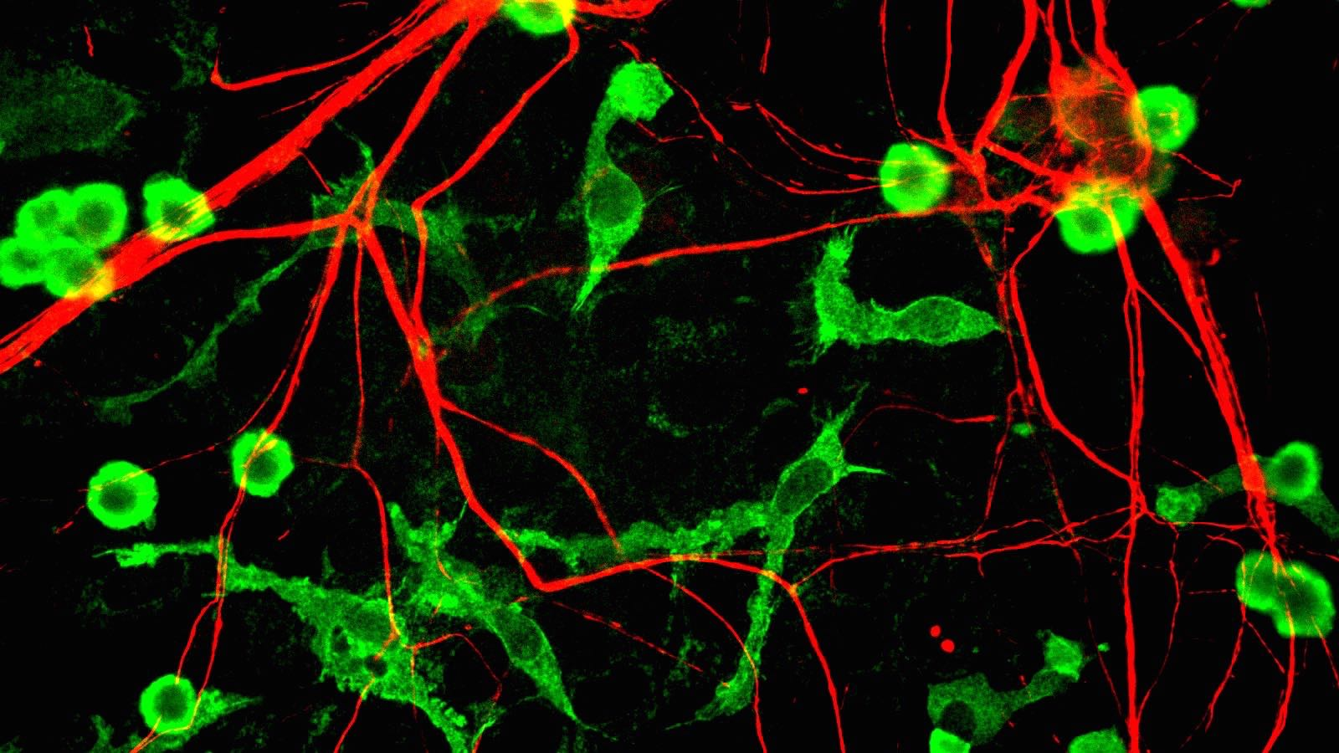
Microglia, seen here stained green, are part of the brain's specialized immune system.
One reason why ongoing inflammation is assumed to be driving—if not instigating—brain diseases is that activated microglia are seen in the brains of these patients. However, activated microglia are not always bad. They also help protect it by shielding damaged areas from healthy regions, clearing debris from the brain, and initiating other complex anti-inflammatory processes that are far from fully understood. Bielekova points out that, “if you just see immune cells in the tissue, it’s very hard to say if they are playing bad guys or good guys.” In fact, a recent study published by the Yale School of Medicine in Nature Communications shows that microglia, at least in mice, appear to protect the brain by walling off the plaques from the surrounding environment. It’s possible, then, that tamping down microglia activation could actually make things worse.
The difficulty of figuring out how to intervene in an immune response without turning off necessary functions may be just one reason why we haven’t seen major successes yet. Experts have pointed out a number of other reasons why so many trials have failed, from animal models that don’t translate well to humans and clinical trials that some would argue were poorly designed to the fact that once an inflammatory immune response has been well established, it becomes much harder to resolve.
“Once you have this fully established chronic inflammation, it’s much, much more difficult to deliver effective treatments to those areas,” Bielekova says. “In multiple sclerosis, it is very clear that whichever drug you take that is efficacious, the efficacy decreases as you delay the treatment. So if you use the treatment very, very early on, every drug looks like a winner. But you wait just a couple of years and you take patients that are now three four years longer in the disease duration you may lose 50% efficacy of your drug.”

Glimmers of Hope
Disappointing results aside, there are hints that intervening early to tamp down inflammation can be helpful. The same data analysis that showed NSAIDs can actually speed up the progression of Alzheimer’s in patients in the advanced stages of the disease also revealed that those who started taking NSAIDs regularly in midlife, when their brains were healthier, had slower cognitive decline.
Other approaches built around intervening early have yielded similar results. For example, last summer Genentech announced the results of a phase II trial testing the efficacy of crenezumab to treat Alzheimer’s disease. Crenezumab is an antibody that binds to amyloid beta, the protein that makes up the plaques scattered throughout the brain that are one of the main visible features of Alzheimer’s. The theory behind this choice of antibody was that it would stimulate microglia just enough to begin clearing the plaques, but not so much so that these immune cells would launch a major inflammatory response. While this phase II trial failed to meet its targets, patients in the early stages of the disease who had been given large doses showed slower cognitive decline.
Damir Janigro, a blood brain barrier researcher at Cleveland Clinic who studies traumatic brain injury and epilepsy, has a very different take on how to approach brain diseases linked with inflammation. He considers both of these diseases to be “blood brain barrier” diseases because repeated seizures and traumatic brain injury can damage the blood brain barrier, making it leakier. That means that not only can substances that don’t belong inside the brain slip through, materials from inside the brain can travel to the rest of the body.
“The blood brain barrier shields your brain, which is good for you. But then it’s bad for you if you leak a piece of your brain and this is considered an enemy” by the rest of your immune system, he says. Janigro is part of what he calls a “vocal minority” of researchers who look at inflammation outside the brain as being another cause of inflammation inside the brain—and potentially even a better target for treatment. “Neuroinflammation is probably bad for you. But it’s a very hard target to go after. Everybody who does is surprised that it fails, like the Alzheimer’s trial in pulling amyloid from the brain.”
We’re still early in our understanding of how the brain’s immune system works, when it is damaging, and when it is protective. If inflammation is the common element in brain diseases, it may turn out that understanding how to intervene successfully in one disease will make it possible to use similar therapeutic approaches across many. But, because we don’t fully understand how the unfathomably complex immune system works, it is likely to be a long and difficult journey before we find ways to intervene safely and effectively.
“If you look at the range of disorders and diseases there’s probably a continuum where in some it plays little or no role, with some it’s in between,” Meier says. “You can go too far with any of these unifying themes. There’s a natural tendency to want to do so. But I do think the inflammation story is not going away. I think it’s real.”

